***Backend Development***



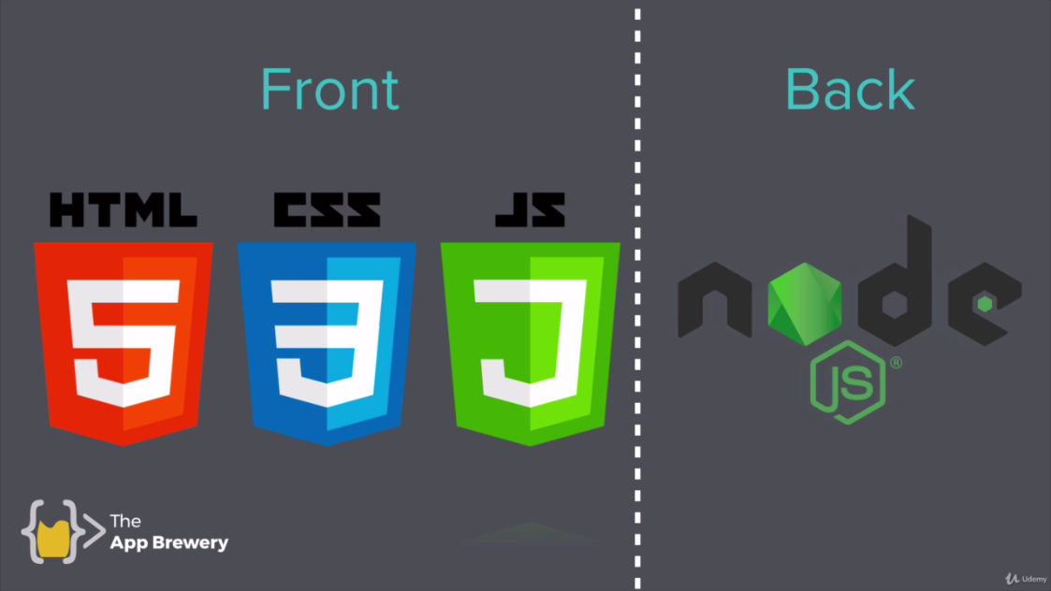



A server is **a computer program or device that provides a service to another computer program and its user, also known as the client**.

Like CSS, JS, HTML

**Database:**

* Stores data

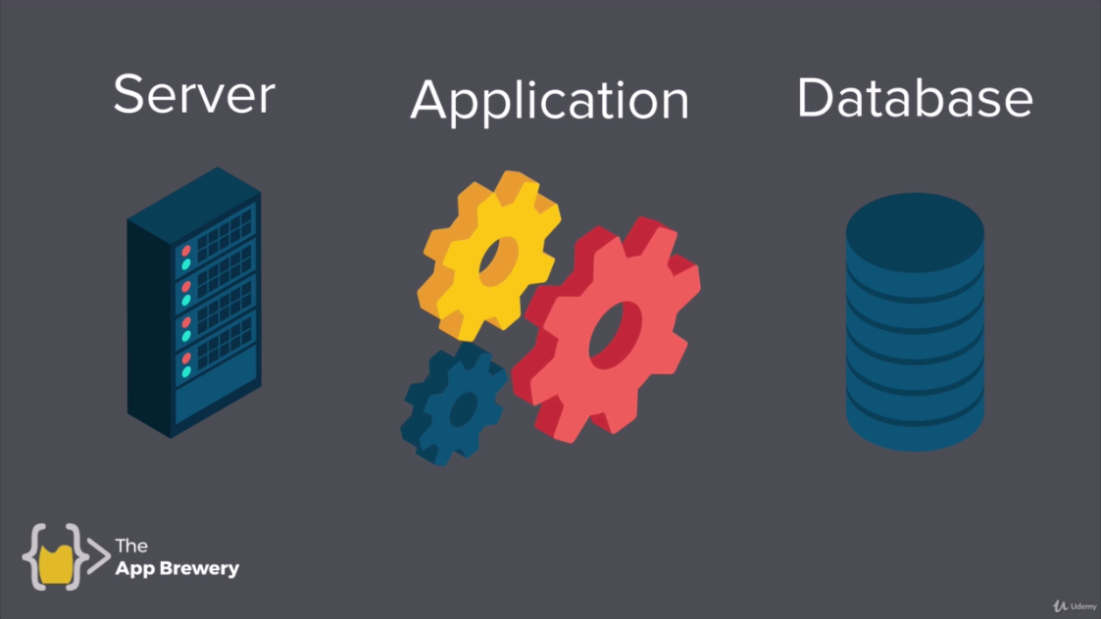

**Applications:**

* Making payments
* Calculating flight prices

Let’s look at the Eventbrite Web-Application

<https://www.eventbrite.com>

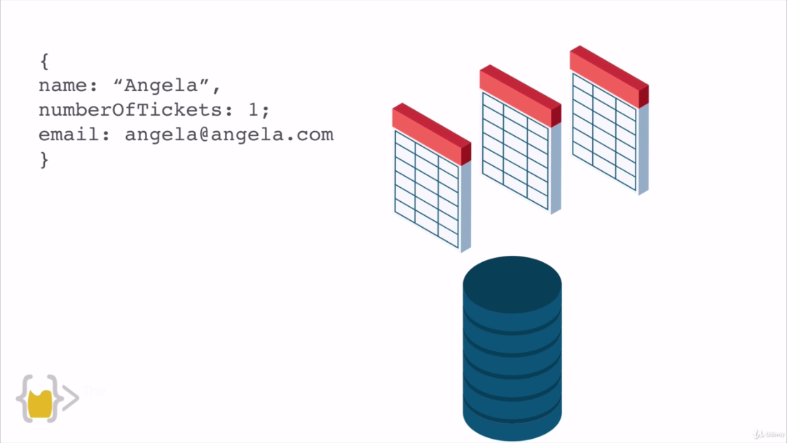

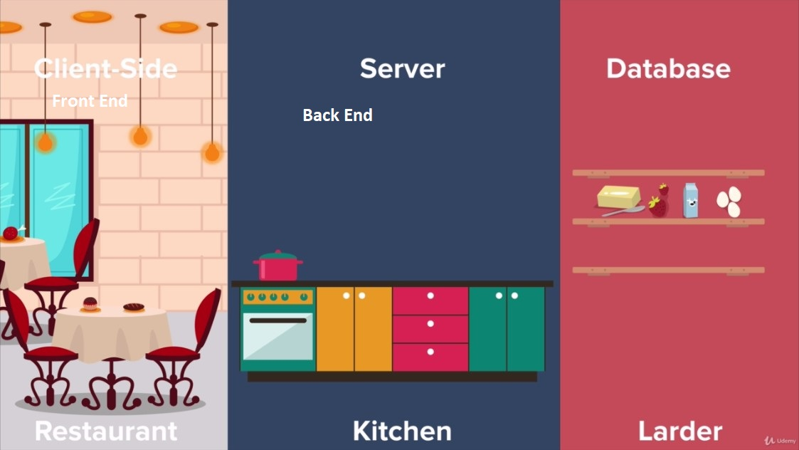

On back end, there’s a lot of technologies like

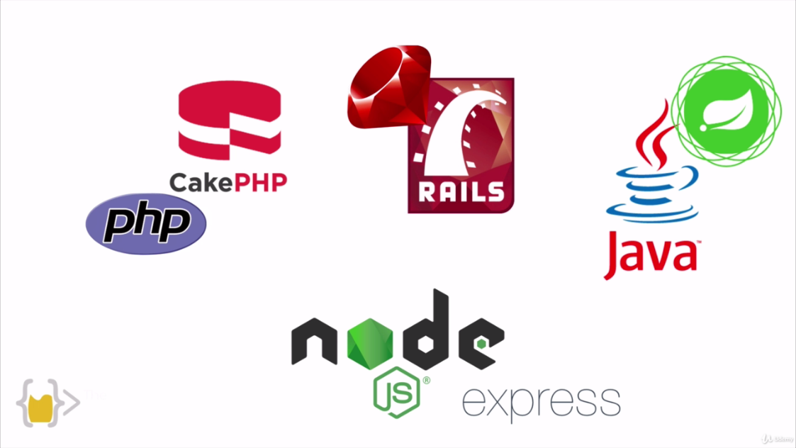

No JS runs on JavaScript. Move on **node JS**

